**Representing INSTANCE and ISA Relationships**

Specific attributes **instance** and **isa**play important role particularly in a useful form of reasoning called property inheritance.

**The predicates instance and isa explicitly captured the relationships they are used to express, namely class membership and class inclusion.**

Below figure shows the first five sentences of the last section represented in logic in three different ways.

The first part of the figure contains the representations we have already discussed. In these representations, class membership is represented with unary predicates (such as Roman), each of which corresponds to a class.

Asserting that P(x) is true is equivalent to asserting that x is an instance (or element) of P.

The second part of the figure contains representations that use the **instance**predicate explicitly.

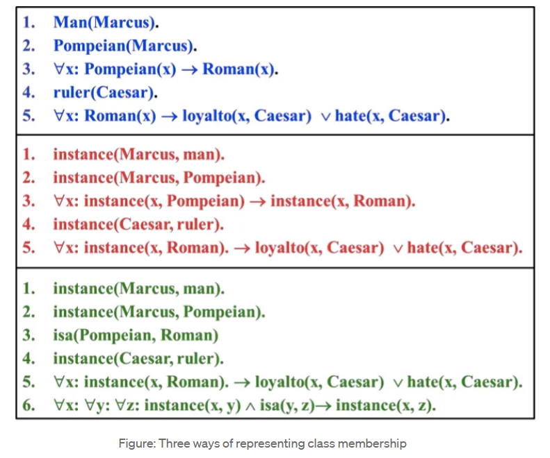

The predicate **instance**is a binary one, whose first argument is an object and whose second argument is a class to which the object belongs.

But these representations do not use an explicit **isa**predicate.

Instead, subclass relationships, such as that between Pompeians and Romans, are described as shown in sentence 3.

The implication rule states that if an object is an instance of the subclass Pompeian then it is an instance of the superclass Roman.

Note that this rule is equivalent to the standard set-theoretic definition of the subclass-superclass relationship.

The third part contains representations that use both the **instance**and**isa**predicates explicitly.

The use of the **isa**predicate simplifies the representation of sentence 3, but it requires that one additional axiom (shown here as number 6) be provided.